

**BeautéPanda: Android Application for Beauty Enthusiasts**

**BIT304 FINAL YEAR PROJECT I**

**REQUIREMENT ANALYSIS**

(E1500352) Ayu Chrisniyanti

(E1500367) Lovely

Submitted to the

FACULTY OF COMPUTING AND DIGITAL TECHNOLOGY

(SCHOOL OF INFORMATION AND COMMUNICATION TECHNOLOGY)

In partial fulfilment of the requirements

for the degree of

Bachelor of Information Technology (HONS)

HELP UNIVERSITY

SEPTEMBER - DECEMBER 2018

**CHAPTER 3: REQUIREMENT ANALYSIS**

* 1. **Introduction**

The requirement analysis is a major process in software engineering which provides an appropriate mechanism to understand what user wants from the system, analyse the user needs, assess eligibility of the system for the user, and so on (Moertini, Suhok, Heriyanto, & Nugroho, 2014). It is very important to make requirement analysis in developing a mobile application because it will help us as the developer to analyse what user needs from the system and meet those requirements so that the application we develop will be working as expected.

This chapter will discuss about the requirements summary which will be the summarization of all the requirements that are reflect accurately the details of the system. Beside, based on the system’s functions, requirements can be classified into functional and non-functional which in functional requirement, it will be specified all the prior function of the system and it describe what the system should do.

The function of the system also will be explained with a use case diagram, high-level use case, and expanded use case to describe in more details of the system’s function.In non-functional requirement, it is described how the system works, define the system properties or attributes and constraints from technical requirements to security requirements which it is very important while developing an application.

* 1. **Requirements Summary**

BeautéPanda is an android application for beauty enthusiasts. The main purpose of this application is to facilitate makeup artists and beauty salons to promote their service and to help customers to find them and contact them. The proposed application will have three users, which are makeup artists, customer and admin. Admin can post news about beauty trends, post announcements related to special promotions or events, and remove inappropriate feedback.

Makeup artist can create portfolio which includes information about their location and price, and photos of their makeup results. The application will also ask makeup artists to include some keywords that are suitable to describe their service, so that it will be easier for customer to search and find them. Moreover, makeup artists can view beauty news, make appointments with customer, reply feedback given by customer and reply direct message that are sent by customer.

Customer can search for makeup artists, view their portfolio and send message to them for more detailed information. They can also give rating and leave feedback for makeup artists whose service they have ordered. Additionally, customer can view beauty news and confirm to appointment that has been made by the makeup artist (which means they have agreed to meet so the service can be delivered). Last but not least, both customer and makeup artist can report feedback that is inappropriate e.g. racist, sexist, etc.

The functions in the application that are handled by the admin are:

* **Manage News:** admin can post, update or delete news about beauty trends
* **Manage Announcements:** admin can post, update or delete announcements about promotions or special events
* **Remove Feedback:** admin can delete feedback given by customer to makeup artist if it is inappropriate

The functions in the application that can be done by the makeup artists are:

* **Manage Portfolio:** makeup artist can post, update and delete information and photos about themselves to promote their service
* **Reply Feedback:** makeup artist can reply feedback given by customers
* **Reply Message:** makeup artist can reply message sent by customers
* **View Beauty News:** view beauty-related news to increase their knowledge about beauty industry
* **Create Appointment:** after customer and makeup artist discuss about the service through messaging feature, and they have agreed to meet up, the makeup artist can create appointment which means the appointment will be officially recorded in the application. Some information should be included when creating the appointment, such as name of customer, agreed price, the meet-up time and place, and type of service to be delivered.
* **Report Feedback:** makeup artist can report the feedback given by customer if it is inappropriate.

The functions in the application that can be done by the customers are:

* **View Portfolio:** customer can view portfolio of the makeup artist
* **Give Feedback:** customer can give feedback to makeup artist which service has been used
* **Give Rating:** customer can give rating to makeup artists which service has been used
* **Send Message:** customers can sent message to makeup artist to ask more information
* **View Beauty News:** view beauty-related news to increase their knowledge about beauty industry
* **Confirm to Appointment:** customer should confirm to appointment that have been created by makeup artists before the application officially record the appointment.
* **Report Feedback:** customer can report the feedback given by other customer if it is inappropriate.
  1. **Functional Requirements**

The functions of the system are described in the functional requirements, which are:

1. **Register**

Makeup artists that want to offer their service using this application must register and provide basic information about themselves (name, date of birth, email address, username, password, email address, etc.).

Account verification will be done by sending email to the email address that is used to register and user has to confirm it.

After that, makeup artists can start using this application. For regular customer, they don’t have to register if they just want to view portfolio of the makeup artists and view beauty news. But if the customer wanted to send message, make appointment, give feedback and give rating, the customer has to be registered first.

1. **Login**

Both admin and users has to login with their account. But if the customer just wanted to view portfolio of the makeup artists and view beauty news, they don’t have to be logged in. There will special login process for admin because the functions being accessed are different from regular users. To log in, admin and both users has to enter their username or email address and password.

1. **Edit Profile**

This function will let both users to edit their profile.

1. **Edit Portfolio**

This function is only for makeup artist, which is for them to create, edit, and delete their portfolio.

1. **View Portfolio**

This function will let both users and admin to view portfolio of the makeup artist.

1. **Search for Makeup Artist**

This function will let both users and admin to search for makeup artist.

1. **Send Message**

This function is for customer to send message to the makeup artist.

1. **Reply Message**

This function is for makeup artist to reply the message that has been sent by customer.

1. **Make Appointment**

This function is for makeup artist to make appointment.

1. **Confirm Appointment**

This function is for customer to confirm the appointment that has been made by makeup artist.

1. **Give Feedback**

This function is for customer to give feedback to makeup artist which service has been used.

1. **Reply Feedback**

This function is for makeup artist to reply feedback given by customer.

1. **Give Rating**

This function is for customer to give rating to makeup artist which service has been used.

1. **Edit Beauty News**

This function is only admin, which is for them to post, edit, and delete beauty news.

1. **View Beauty News**

This function will let both users and admin to view beauty news.

1. **Edit Announcement**

This function is only for admin, which is for them to post, edit, and delete announcements.

1. **View Announcement**

This function will let both users and admin to view announcements.

1. **Report Feedback**

This function will allow users (customer and makeup artist) to report feedback that is inappropriate.

1. **Remove Feedback**

This function is only for admin, which is for them to remove inappropriate feedbacks.

1. **Logout**

This function will let both users and admin to logout of the system.

* + 1. **Use Case Diagram**

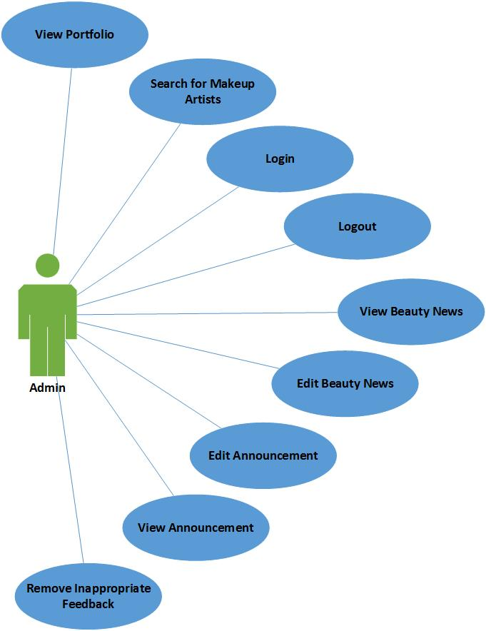

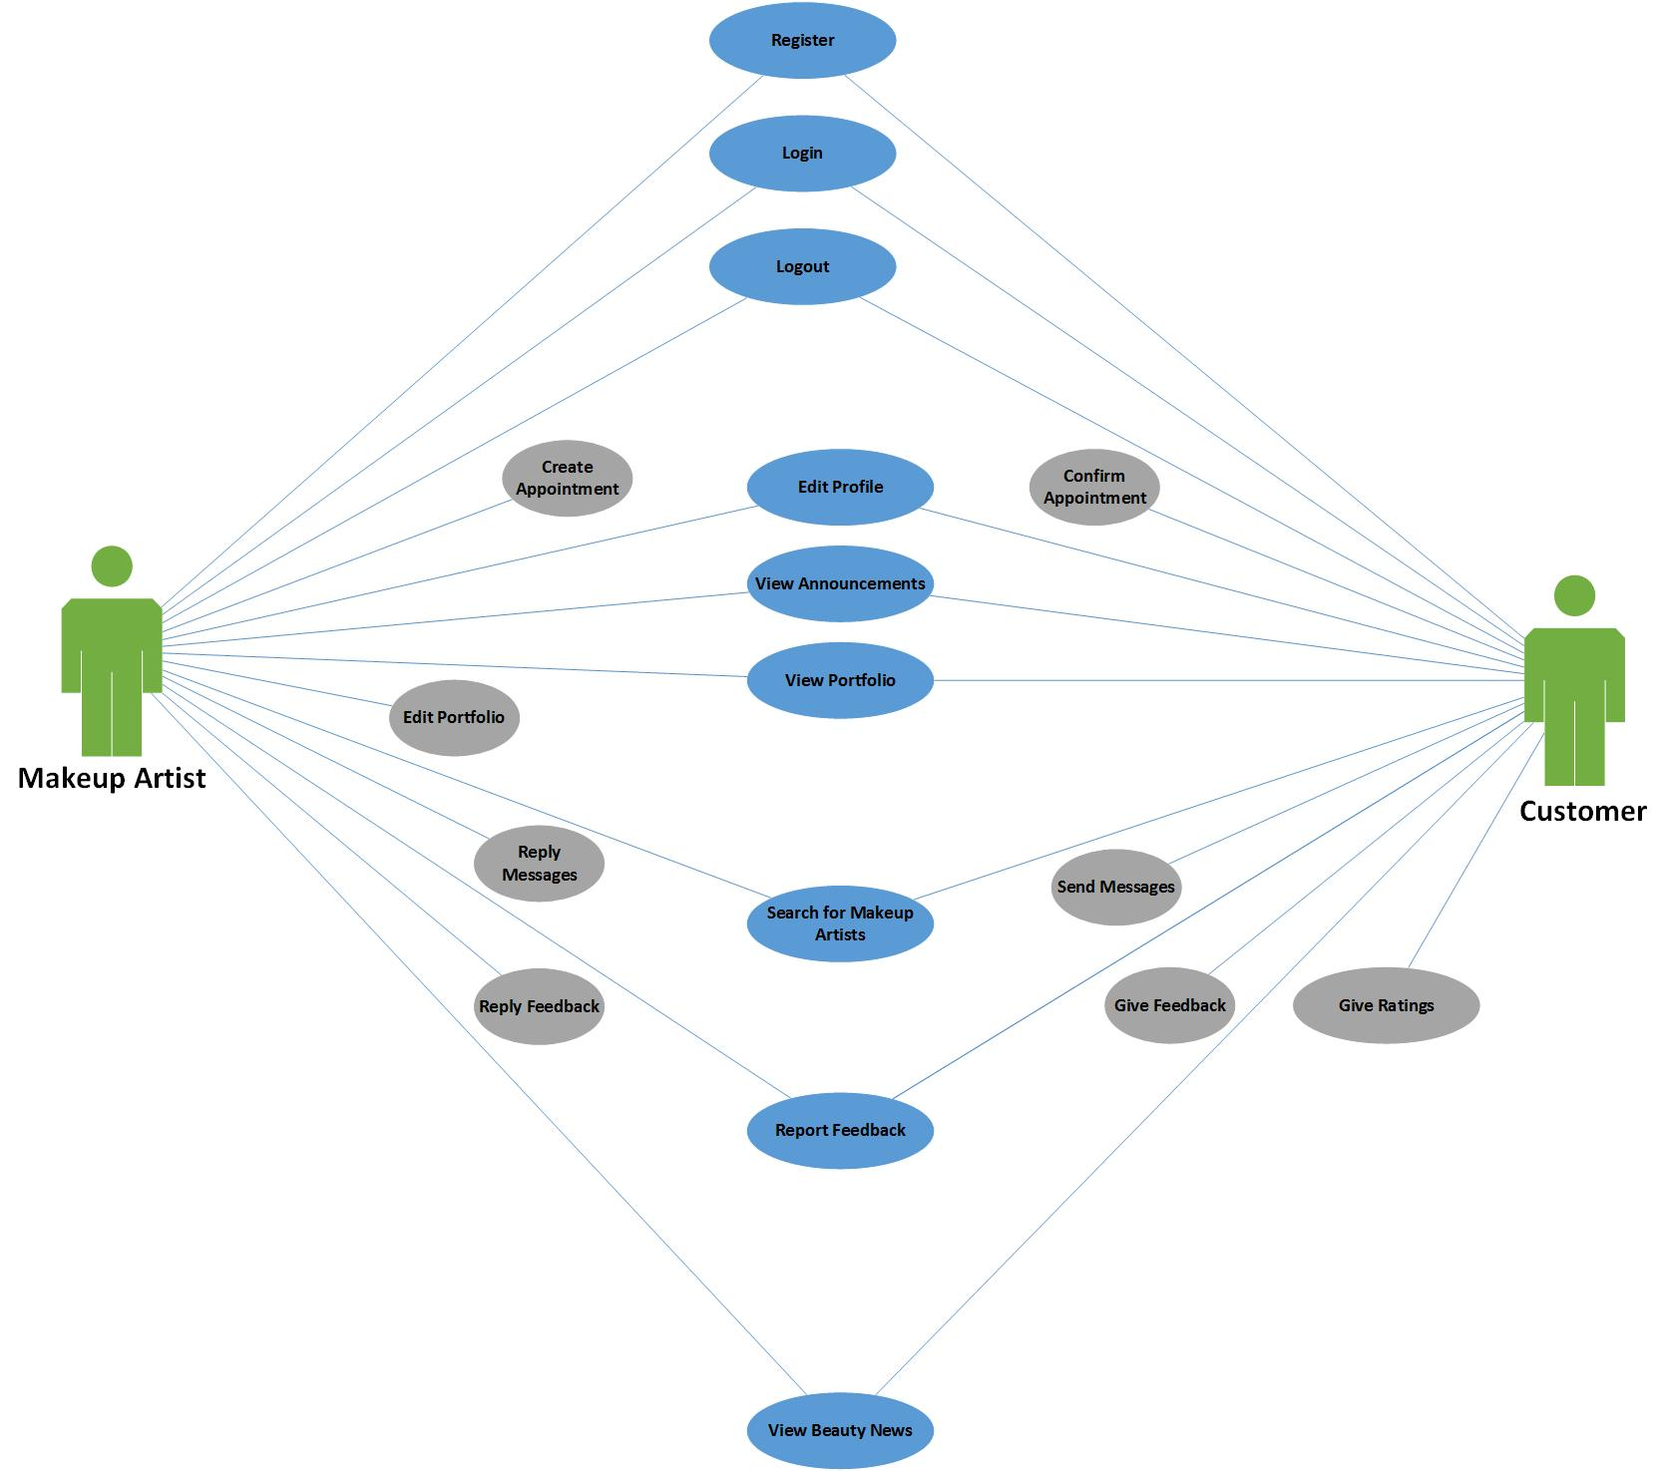

* + 1. **High-Level Use Case**

|  |  |
| --- | --- |
| **Use Case** | Register |
| **Goal in Context** | User that has not yet registered can create an account |
| **Primary Actor**  **Secondary Actor** | User  - |
| **Description** | Unregistered user must provide their personal data to fill in the registration form and the newly created account must be verified with email. |

|  |  |
| --- | --- |
| **Use Case** | Login |
| **Goal in Context** | User and admin can login to the application |
| **Primary Actor**  **Secondary Actor** | User and admin  - |
| **Description** | To login to the application, user and admin must provide their username or email address and password |

|  |  |
| --- | --- |
| **Use Case** | Edit Profile |
| **Goal in Context** | User can edit their personal information that is entered in the application |
| **Primary Actor**  **Secondary Actor** | User  - |
| **Description** | User can edit profile picture, username, password, name, address, phone number, address, and birth of date. |

|  |  |
| --- | --- |
| **Use Case** | Edit Portfolio |
| **Goal in Context** | User can edit their portfolio |
| **Primary Actor**  **Secondary Actor** | User  - |
| **Description** | User that is registered as makeup artist can fill their portfolio with photos and information that they want to display, and it can be edited as needed. |

|  |  |
| --- | --- |
| **Use Case** | View Portfolio |
| **Goal in Context** | User and admin can see the portfolio of makeup artist that has registered to the application |
| **Primary Actor**  **Secondary Actor** | User and admin  - |
| **Description** | User and admin can select certain service (makeup or hairdo or nails), select a category (e.g. wedding or party), and the application will show a list of makeup artists. User can select a makeup artist to view the portfolio. |

|  |  |
| --- | --- |
| **Use Case** | Search for Makeup Artist |
| **Goal in Context** | User and admin can search for specific makeup artist |
| **Primary Actor**  **Secondary Actor** | User and admin  - |
| **Description** | User and admin can search for specific service or makeup artist by entering a keyword in the search bar. |

|  |  |
| --- | --- |
| **Use Case** | Send Message |
| **Goal in Context** | User can send message to makeup artist |
| **Primary Actor**  **Secondary Actor** | User  - |
| **Description** | User that is registered as customer can send message to makeup artist to ask for more detailed information. |

|  |  |
| --- | --- |
| **Use Case** | Reply Message |
| **Goal in Context** | User can reply message from customer |
| **Primary Actor**  **Secondary Actor** | User  - |
| **Description** | User that is registered as makeup artist can reply message to customers to answer their questions. |

|  |  |
| --- | --- |
| **Use Case** | Make Appointment |
| **Goal in Context** | User can make an appointment with customer |
| **Primary Actor**  **Secondary Actor** | User  - |
| **Description** | User that is registered as makeup artist can make an appointment with customer by clicking ‘create appointment’ option and entering the time and place, the service to be delivered and the price. |

|  |  |
| --- | --- |
| **Use Case** | Confirm Appointment |
| **Goal in Context** | User can confirm appointment to makeup artist. |
| **Primary Actor**  **Secondary Actor** | User  - |
| **Description** | User that is registered as customer can confirm the appointment that has been created by makeup artist. After the user has confirmed, the application will record the appointment as an order that is in progress for both users. |

|  |  |
| --- | --- |
| **Use Case** | Give Feedback |
| **Goal in Context** | User can give feedback to makeup artist |
| **Primary Actor**  **Secondary Actor** | User  - |
| **Description** | User that is registered as customer can give feedback to makeup artist whose service has been used. |

|  |  |
| --- | --- |
| **Use Case** | Reply Feedback |
| **Goal in Context** | User can reply feedback from customer |
| **Primary Actor**  **Secondary Actor** | User  - |
| **Description** | User that is registered as makeup artist can reply to feedbacks that are left by customers. |

|  |  |
| --- | --- |
| **Use Case** | Give Rating |
| **Goal in Context** | User can give rating to makeup artist |
| **Primary Actor**  **Secondary Actor** | User  - |
| **Description** | User that is registered as customer can give rating to makeup artist whose service has been used. |

|  |  |
| --- | --- |
| **Use Case** | View Beauty News |
| **Goal in Context** | User and admin can view beauty related news |
| **Primary Actor**  **Secondary Actor** | User and admin  - |
| **Description** | User and admin can open news section to read the latest trends and news to increase their knowledge. |

|  |  |
| --- | --- |
| **Use Case** | Edit Beauty News |
| **Goal in Context** | Admin can edit beauty news |
| **Primary Actor**  **Secondary Actor** | Admin  - |
| **Description** | Admin can add, update or delete beauty news which can be read by user. |

|  |  |
| --- | --- |
| **Use Case** | View Announcement |
| **Goal in Context** | User and admin can view announcement |
| **Primary Actor**  **Secondary Actor** | User and admin  - |
| **Description** | User and admin can view announcement about special events or promotions. |

|  |  |
| --- | --- |
| **Use Case** | Report Feedback |
| **Goal in Context** | User can report inappropriate feedback |
| **Primary Actor**  **Secondary Actor** | User  - |
| **Description** | User can report feedbacks by customers which are inappropriate e.g. racist or sexist. |

|  |  |
| --- | --- |
| **Use Case** | Edit Announcement |
| **Goal in Context** | Admin can edit announcement |
| **Primary Actor**  **Secondary Actor** | Admin  - |
| **Description** | Admin can add, update or delete announcement. |

|  |  |
| --- | --- |
| **Use Case** | Remove Feedback |
| **Goal in Context** | Admin can remove inappropriate feedback |
| **Primary Actor**  **Secondary Actor** | Admin  - |
| **Description** | Admin can remove feedbacks by customers which are inappropriate e.g. racist. |

|  |  |
| --- | --- |
| **Use Case** | Logout |
| **Goal in Context** | User and admin can logout from their account |
| **Primary Actor**  **Secondary Actor** | User and admin  - |
| **Description** | User and admin can logout from their account by selecting the logout button. |

* + 1. **Expanded Use Case**

|  |  |
| --- | --- |
| **Use Case Name** | **Register** |
| **Goal in Context** | User that has not yet registered can create an account |
| **Primary Actor**  **Secondary Actor** | User  - |
| **Typical Course of Events** | |
| **Actor Action** | **System Response** |
| 1. This use case starts when a User clicks the register button | 1. The system will provide two options (customer or makeup artist) to choose from |
| 1. User choose to register as customer or makeup artist | 1. The system will display a registration form based on the user option |
| 1. User fill the registration form with their personal information | 1. System will run validation on the data being input |
|  | 1. A verification email will be sent by the system to the email address used in the registration form |
| 1. User has to open their email and click on the verification link to ensure that the email address used is truly theirs | 1. User account is saved to the database by the system after the verification process |
|  | 1. System will display the main menu which means registration has been successful |
| **Alternatives Course of Events** | |
| 1. A warning message will be displayed if one or more column in the registration form is not filled 2. A warning message will be displayed if the user input invalid email address 3. A warning message will be displayed if the password entered and password confirmation do not match 4. A warning message will be displayed if the password is less than 8 characters | |

|  |  |
| --- | --- |
| **Use Case Name** | **Login** |
| **Goal in Context** | User and admin can login to the application |
| **Primary Actor**  **Secondary Actor** | User and admin  - |
| **Typical Course of Events** | |
| **Actor Action** | **System Response** |
| 1. This use case starts when a User or Admin clicks the login button | 1. The login form will be displayed by the system |
| 1. User or Admin has to fill out the login form with their username or email address and password |  |
| 1. User or Admin can click the login button after finish filling out the form | 1. System will check if the email address or username exist in the database and if the password match |
|  | 1. If the data entered are valid, the system will display the main menu |
| **Alternatives Course of Events** | |
| 1. If the email address or username does not exist in the database, a warning message will be displayed 2. If the inputted password is not correct, a warning message will be displayed | |

|  |  |
| --- | --- |
| **Use Case Name** | **Edit Profile** |
| **Goal in Context** | User can edit their personal information that is entered in the application |
| **Primary Actor**  **Secondary Actor** | User  - |
| **Typical Course of Events** | |
| **Actor Action** | **System Response** |
| 1. This use case starts when a User chooses the profile menu | 1. The system will display the current information of the User |
| 1. User choose which information to edit and can click on pencil icon to edit | 1. The system will allow User to edit the selected information |
| 1. User update his/her personal information and click done when he/she has finished | 1. System will save the data that has been updated |
|  | 1. System will display message to notify User that changes have been saved |
| **Alternatives Course of Events** | |
| - | |

|  |  |
| --- | --- |
| **Use Case Name** | **Edit Portfolio** |
| **Goal in Context** | User can edit their portfolio |
| **Primary Actor**  **Secondary Actor** | User  - |
| **Typical Course of Events** | |
| **Actor Action** | **System Response** |
| 1. This use case starts when a User that registered as a makeup artist open my portfolio page | 1. The system will display photos, videos or information that have been posted by the User |
|  | 1. The system will display add, edit and delete icons which User can choose from |
| 1. User chooses the action that he/she wants | 1. The system will allow User to add new information or edit or delete existing information |
| 1. User executes the action he/she wants and click done when he/she has finished | 1. The system will save the data that has been updated |
|  | 1. The system will display message to notify User that changes have been saved |
| **Alternatives Course of Events** | |
| 1. If the User has not posted anything yet, the page will be empty with message that nothing has been posted. | |

|  |  |
| --- | --- |
| **Use Case Name** | **View Portfolio** |
| **Goal in Context** | User and admin can see the portfolio of makeup artist that has registered to the application |
| **Primary Actor**  **Secondary Actor** | User and admin  - |
| **Typical Course of Events** | |
| **Actor Action** | **System Response** |
| 1. This use case starts when a User and Admin open the home page | 1. The system will display three types of services, which are makeup, hairdo and nails |
| 1. User or Admin chooses the desired service | 1. The system will display the specific categories of the desired service |
| 1. User or Admin chooses the desired category | 1. The system will display list of makeup artist that is available to deliver the service |
| 1. User or Admin clicks on the profile of one makeup artist | 1. The system will display the portfolio of the selected makeup artist |
| **Alternatives Course of Events** | |
| - | |

|  |  |
| --- | --- |
| **Use Case Name** | **Search for Makeup Artist** |
| **Goal in Context** | User and admin can search for specific makeup artist |
| **Primary Actor**  **Secondary Actor** | User and admin  - |
| **Typical Course of Events** | |
| **Actor Action** | **System Response** |
| 1. This use case starts when a User and Admin clicks on the search bar and enter what he/she is looking for |  |
| 1. User or Admin clicks the search icon | 1. The system will display the results that match with the keyword being searched |
| **Alternatives Course of Events** | |
| 1. If the keyword being entered does not match with any data in the database, the system will display message to notify User or Admin that no data is found | |

|  |  |
| --- | --- |
| **Use Case Name** | **Send Message** |
| **Goal in Context** | User can send message to makeup artist |
| **Primary Actor**  **Secondary Actor** | User  - |
| **Typical Course of Events** | |
| **Actor Action** | **System Response** |
| 1. This use case starts when a User that registered as customer has selected a makeup artist and view his/her portfolio |  |
| 1. User selects message icon that appears when viewing the makeup artist portfolio | 1. The system will redirect the user to a chat room with the selected makeup artist as the recipient |
| 1. User types the message and can click send icon to send the message | 1. The system will send the message to the makeup artist |
| **Alternatives Course of Events** | |
| - | |

|  |  |
| --- | --- |
| **Use Case Name** | **Reply Message** |
| **Goal in Context** | User can reply message from customer |
| **Primary Actor**  **Secondary Actor** | User  - |
| **Typical Course of Events** | |
| **Actor Action** | **System Response** |
| 1. This use case starts when a User that registered as makeup artist open the message menu | 1. The system will displayed the list of messages that have been sent by customers |
| 1. User can select a message that he/she wants to reply | 1. The system will display the content of the selected message |
| 1. User types message and can click send icon to reply the message | 1. The system will send the reply message to the customer |
| **Alternatives Course of Events** | |
| - | |

|  |  |
| --- | --- |
| **Use Case Name** | **Make Appointment** |
| **Goal in Context** | User can make an appointment with customer |
| **Primary Actor**  **Secondary Actor** | User  - |
| **Typical Course of Events** | |
| **Actor Action** | **System Response** |
| 1. This use case starts when a User that registered as makeup artist open the message menu | 1. The system will displayed the list of messages that have been sent by customers |
| 1. User can open a conversation with customer that want to make appointment | 1. The system will display the content of the selected message |
| 1. User can clicks add icon from the chat room to make an appointment | 1. The system will display a form for the user to fill the appointment details |
| 1. User can fill the details of the appointment |  |
| 1. User can click save icon to after filling out the form | 1. The system will check if the information being entered are valid |
|  | 1. The system will save the appointment and notify customer that the makeup artist has made an appointment with the customer and he/she has to confirm it |
| **Alternatives Course of Events** | |
| 1. If one of the columns in the form is empty, a warning message will be displayed | |

|  |  |
| --- | --- |
| **Use Case Name** | **Confirm Appointment** |
| **Goal in Context** | User can confirm appointment to makeup artist. |
| **Primary Actor**  **Secondary Actor** | User  - |
| **Typical Course of Events** | |
| **Actor Action** | **System Response** |
| 1. This use case starts when a User that registered as customer receive notification that a makeup artist has made appointment with the User |  |
| 1. User clicks on the notification | 1. The system will display the message menu and open the conversation of the User with the makeup artist, and display the appointment and its details |
| 1. User can clicks on the appointment and read its details to make sure everything is correct |  |
| 1. User can clicks on the appointment and clicks on confirmation button | 1. The system will save the appointment with ‘confirmed status’ |
|  | 1. The system will send notification to makeup artist that the User has confirmed the order |
|  | 1. The system will put the appointment in ongoing order list for the User and makeup artist |
| **Alternatives Course of Events** | |
| - | |

|  |  |
| --- | --- |
| **Use Case Name** | **Give Feedback** |
| **Goal in Context** | User can give feedback to makeup artist |
| **Primary Actor**  **Secondary Actor** | User  - |
| **Typical Course of Events** | |
| **Actor Action** | **System Response** |
| 1. This use case starts when a User that registered as customer has received the service from the makeup artist | 1. The system will send notification that the service has been delivered and the transaction is done |
| 1. User clicks on the notification | 1. The system will display the makeup artist that has done the service, a button for customer to give feedback and star icon to give rating |
| 1. User clicks on the give feedback button | 1. The system will display a textbox for User to type the feedback |
| 1. User fills the textbox with the feedback |  |
| 1. User can clicks on send button to submit the feedback | 1. The system will save the feedback and post it on the portfolio of the makeup artist |
|  | 1. The system will send notification to makeup artist that the User has left a feedback |
| **Alternatives Course of Events** | |
| - | |

|  |  |
| --- | --- |
| **Use Case Name** | **Reply Feedback** |
| **Goal in Context** | User can reply feedback from customer |
| **Primary Actor**  **Secondary Actor** | User  - |
| **Typical Course of Events** | |
| **Actor Action** | **System Response** |
| 1. This use case starts when a User that registered as makeup artist receive a notification that a customer has given a feedback |  |
| 1. User clicks on the notification | 1. The system will display the feedback and reply button |
| 1. User clicks on the reply button | 1. The system will display a textbox for User to reply the feedback |
| 1. User fills the textbox with the reply |  |
| 1. User can clicks on send button to submit the reply | 1. The system will save the reply and post it under the feedback |
|  | 1. The system will send notification to customer that the User has replied to the feedback |
| **Alternatives Course of Events** | |
| - | |

|  |  |
| --- | --- |
| **Use Case Name** | **Give Rating** |
| **Goal in Context** | User can give rating to makeup artist |
| **Primary Actor**  **Secondary Actor** | User  - |
| **Typical Course of Events** | |
| **Actor Action** | **System Response** |
| 1. This use case starts when a User that registered as customer has received the service from the makeup artist | 1. The system will send notification that the service has been delivered and the transaction is done |
| 1. User clicks on the notification | 1. The system will display the makeup artist that has done the service, a button for customer to give feedback, and star icon to give rating |
| 1. User clicks on the star icon | 1. The system will display five empty stars |
| 1. User fills how many stars to give to the makeup artist based on quality of the service |  |
| 1. User can clicks on send button to submit the rating | 1. The system will save the rating and send notification to the makeup artist |
|  | 1. The system will display the average rating of the makeup artist on his/her portfolio |
| **Alternatives Course of Events** | |
| - | |

|  |  |
| --- | --- |
| **Use Case Name** | **View Beauty News** |
| **Goal in Context** | User and admin can view beauty related news |
| **Primary Actor**  **Secondary Actor** | User and admin  - |
| **Typical Course of Events** | |
| **Actor Action** | **System Response** |
| 1. This use case starts when a User and Admin open the news page | 1. The system will display list of news that are related to beauty trends |
| 1. User or Admin clicks on the desired news to be read | 1. The system will open the news and display the article |
| **Alternatives Course of Events** | |
| 1. If no news has been posted yet, the page will be empty with message that nothing has been posted. | |

|  |  |
| --- | --- |
| **Use Case Name** | **Edit Beauty News** |
| **Goal in Context** | Admin can edit beauty news |
| **Primary Actor**  **Secondary Actor** | Admin  - |
| **Typical Course of Events** | |
| **Actor Action** | **System Response** |
| 1. This use case starts when Admin open the news page | 1. The system will display list of news that are related to beauty trends |
|  | 1. The system will display add, edit and delete icons which Admin can choose from |
| 1. Admin chooses the action that he/she wants | 1. The system will allow Admin to add new news or edit or delete existing news |
| 1. Admin executes the action he/she wants and click done when he/she has finished | 1. The system will save the data that has been updated |
|  | 1. The system will display message to notify Admin that changes have been saved |
| **Alternatives Course of Events** | |
| 1. If no news has been posted yet, the page will be empty with message that nothing has been posted. | |

|  |  |
| --- | --- |
| **Use Case Name** | **View Announcement** |
| **Goal in Context** | User and admin can view announcement |
| **Primary Actor**  **Secondary Actor** | User and admin  - |
| **Typical Course of Events** | |
| **Actor Action** | **System Response** |
| 1. This use case starts when User and Admin open the home page and scroll down to announcement section | 1. The system will display list of announcements related to special events or promotions |
| 1. User or Admin clicks on the desired announcement to be read | 1. The system will open the announcement and display the details |
| **Alternatives Course of Events** | |
| 1. If currently there is no announcement, the page will be empty with message that there is no new announcement. | |

|  |  |
| --- | --- |
| **Use Case Name** | **Edit Announcement** |
| **Goal in Context** | Admin can edit announcement |
| **Primary Actor**  **Secondary Actor** | Admin  - |
| **Typical Course of Events** | |
| **Actor Action** | **System Response** |
| 1. This use case starts when Admin open the home page and scroll down to announcement section | 1. The system will display list of announcements related to special events or promotions |
|  | 1. The system will display add, edit and delete icons which Admin can choose from |
| 1. Admin chooses the action that he/she wants | 1. The system will allow Admin to add new announcement or edit or delete existing announcement |
| 1. Admin executes the action he/she wants and click done when he/she has finished | 1. The system will save the data that has been updated |
|  | 1. The system will display message to notify Admin that changes have been saved |
| **Alternatives Course of Events** | |
| 1. If currently there is no announcement, the page will be empty with message that there is no new announcement. | |

|  |  |
| --- | --- |
| **Use Case Name** | **Report Feedback** |
| **Goal in Context** | User can report inappropriate feedback |
| **Primary Actor**  **Secondary Actor** | User  - |
| **Typical Course of Events** | |
| **Actor Action** | **System Response** |
| 1. This use case starts when User open a portfolio of a makeup artist and view the feedbacks |  |
| 1. User see an inappropriate feedback and he/she can select report option to report it | 1. The system will display message that asks User reason why he/she report the feedback |
| 1. User types in the reason why the feedback is inappropriate |  |
| 1. User selects submit button | 1. The system will display save the report and send it to admin to review it |
| **Alternatives Course of Events** | |
| - | |

|  |  |
| --- | --- |
| **Use Case Name** | **Remove Feedback** |
| **Goal in Context** | Admin can remove inappropriate feedback |
| **Primary Actor**  **Secondary Actor** | Admin  - |
| **Typical Course of Events** | |
| **Actor Action** | **System Response** |
| 1. This use case starts when Admin open report page | 1. The system will display list of report from User |
| 1. Admin will review the reported feedback and see whether it is really inappropriate or not |  |
| 1. If the feedback is really inappropriate, admin can select it and click remove button | 1. The system will display message that feedback has been successfully removed |
| **Alternatives Course of Events** | |
| - | |

|  |  |
| --- | --- |
| **Use Case Name** | **Logout** |
| **Goal in Context** | User and admin can logout from their account |
| **Primary Actor**  **Secondary Actor** | User and admin  - |
| **Typical Course of Events** | |
| **Actor Action** | **System Response** |
| 1. The use case begins when User or Admin clicks the logout button from the home page | 1. The system will display message asking if the User or Admin really wants to log out |
| 1. User or Admin clicks the yes button | 1. The account will be logout from the application |
| **Alternatives Course of Events** | |
| 1. If User clicks no button, the display message will close and take the User back to his/her home page | |

* 1. **Non-Functional Requirements**
     1. **Technical Requirements**

To develop and operate the mobile application, there are more than two technical requirements that required to be fulfilled. The mobile application will be met with all requirements. There are several technical requirements that need to be fulfilled as follows:

1. **Technical Requirements for The Application Developers**

In developing this mobile application, we decided to use IntelliJ IDEA as IDE. To operate IntelliJ IDEA properly, there are several requirements that need to be fulfilled.

* **Operating System (OS)**

IntelliJ IDEA can be installed in three Operating System such as Windows, Mac OS, and Linux. For Windows, it is required to use 32-bit or 64-bit and versions of Microsoft Windows of 10/8/7/Vista. For Mac OS, it is required to use Mac OS X 10.8.3 or higher versions and only 64-bit are supported to operate IntelliJ IDEA. However, for Linux it can be used in KDE, GNOME, or Unity desktop.

* **RAM**

It needs 2 GB RAM minimum to operate IntelliJ IDEA and it is recommended to use 4 GB RAM or higher to operate IntelliJ IDEA for better experience.

* **Screen Resolutions**

The minimum screen resolution that is requires to run the IntelliJ IDEA is 1024 x 768 pixels

* **Hard Drive Space**

The IntelliJ IDEA requires minimum of 1.5 GB available for hard drive space in order to use the software properly. Also, it required at least 1 GB for caches.

* **Java Development**

This software requires the developer to have a standalone JDK for Java development. However, The Java Runtime Environment (JRE) 1.8 is already bundled with IntelliJ IDEA distribution.

1. **Technical Requirements for The User**

To run and operate the mobile application, there are also some technical requirements for the user that need to be fulfilled. There are the technical requirements for the user as follows:

* **Operating System (OS)**

The user needs 5.1 Lollipop or higher versions of Android to run and operate this application on their smartphones.

* **RAM**

The minimum RAM of the smartphone that is required for the user to run and operate this application is 1 GB of RAM.

* **Screen Resolution**

The minimum screen size of the smartphone for the user to operate or run this application is 5 inch and minimum resolution is 1080 x 1920 pixels. For the aspect ratio is 16:9 which will be supported by this application.

* + 1. **Usability Requirements**

It is very important to have a great experience of usability for a mobile application to fulfil the user’s desire and make the user feel satisfied so the user can operate the application properly and easily. The user interface is one of the aspects that is exist and it give big impact for usability of an application. To meet and fulfil the usability requirements, we decided to design our application’s user interface with Google’s Material Design.

The user interface design of this mobile application will be designed in simple way and attractive so the application can be understood by the user and the user can operate the application easily. For the icon, menu, image, and text that are exists in the application will be placed symmetrical in order to make the design looks presentable and well organized by the users.

A minimalist but attractive design will be appeared, so the user interface will look great and eyes catching. We also use a combination of pink, white, and grey for the colour of the user interface. Flat scheme of colour will be used because flat colour does not too flashy.

* + 1. **Reliability Requirements**

The other requirements for a mobile application is reliability. The application must be reliable so the user can operate and use the application comfortably. To fulfil the requirements, the application must be accessible 24 hours and it be accessed everywhere so the user can access the application anytime they want.

All data in this application will be stored in database so to run this application, the user needs an internet connection to retrieve all data that are stored in the database. However, if the user has good internet connection but the application is not responding, the system will notify the user.

* + 1. **Security Requirements**

The other important aspect for the mobile application is its security to make user feels safe in order of using the application. Because of those reason, access to the system is limited. The user must have an account first, if they want to contact or make appointment with the MUA or beauty salon so the user must register or sign up if they do not have an account or login if they already have an account.

Only admin can access the function that can modify the system such as update announcements, update beauty related news, update features in an application, and others. All communication between client and server will be secured and protected, also all data that are stored in the database will be encrypted to prevent unwanted things such as unauthorized access.

# Reference

Moertini, V. S., Suhok, Heriyanto, S., & Nugroho, C. D. (2014). REQUIREMENT ANALYSIS METHOD OF ECOMMERCE WEBSITES DEVELOPMENT FOR SMALLMEDIUM ENTERPRISES, CASE STUDY: INDONESIA. *International Journal of Software Engineering & Applications (IJSEA)* *, 5* (2), 12 - 13.